The Google colab code that is used for this project:
!pip install -q transformers sentence-transformers lightgbm faiss-cpu
!pip install -q scikit-learn pandas numpy requests pillow tqdm
!pip install -q accelerate

import os
import pandas as pd
import numpy as np
import torch
import requests
from PIL import Image
from io import BytesIO
from tqdm import tqdm
import pickle
import joblib

from sklearn.model_selection import train_test_split
from sklearn.metrics import accuracy_score, classification_report, confusion_matrix
from sklearn.preprocessing import StandardScaler

from sentence_transformers import SentenceTransformer
from transformers import CLIPProcessor, CLIPModel
from transformers import AutoTokenizer, AutoModelForSequenceClassification

import lightgbm as lgb
import faiss

import warnings
warnings.filterwarnings("ignore")

print("✅ All libraries imported")
from google.colab import drive
drive.mount('/content/drive')

# Set working directory
BASE_PATH = "/content/drive/MyDrive/fake_news_project"
os.makedirs(BASE_PATH, exist_ok=True)

print(f"✅ Working directory: {BASE_PATH}")

print("📂 Loading dataset...")
df = pd.read_csv("multimodal_train.tsv", sep="\t")

# Clean data
df = df[["clean_title", "image_url", "2_way_label"]].dropna()

# Sample size (adjust as needed)
SAMPLE_SIZE = 20000 # Use 20k, 30k, or full dataset
df = df.sample(min(SAMPLE_SIZE, len(df)), random_state=42)

print(f"✅ Dataset loaded: {len(df)} samples")
print(f"\n📊 Label distribution:")
print(f" REAL (0): {(df['2_way_label']==0).sum()} ({(df['2_way_label']==0).mean()*100:.1f}%)")
print(f" FAKE (1): {(df['2_way_label']==1).sum()} ({(df['2_way_label']==1).mean()*100:.1f}%)")

df.head()

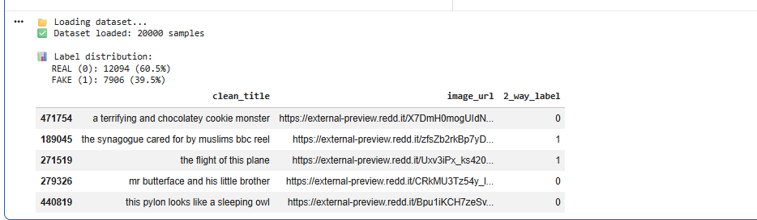
print("\n🔧 Creating evidence corpus...")

# CRITICAL: Use only REAL news as evidence
# This prevents circular reasoning with fake news
evidence_df = df[df["2_way_label"] == 0].copy()

print(f"✅ Evidence corpus: {len(evidence_df)} REAL news articles")
print(f" Training set: {len(df)} total articles")
print(f" Ratio: {len(evidence_df)/len(df)*100:.1f}% real news\n")

o/p:
Creating evidence corpus...
✅ Evidence corpus: 12094 REAL news articles
Training set: 20000 total articles
Ratio: 60.5% real news
device = "cuda" if torch.cuda.is_available() else "cpu"
print(f"🖥️ Device: {device}\n")

# 1️⃣ SBERT (Text Encoder) - Best semantic encoder
print("🔄 Loading SBERT...")
text_model = SentenceTransformer("all-mpnet-base-v2")
print("✅ SBERT loaded (all-mpnet-base-v2)")

# 2️⃣ CLIP (Image-Text Alignment)
print("\n🔄 Loading CLIP...")
clip_model = CLIPModel.from_pretrained("openai/clip-vit-base-patch32").to(device)
clip_processor = CLIPProcessor.from_pretrained("openai/clip-vit-base-patch32")
print("✅ CLIP loaded (vit-base-patch32)")

# 3️⃣ NLI Model (Claim Verification) - This is the smart part!
print("\n🔄 Loading NLI model...")
nli_model_name = "facebook/bart-large-mnli"
nli_tokenizer = AutoTokenizer.from_pretrained(nli_model_name)
nli_model = AutoModelForSequenceClassification.from_pretrained(nli_model_name).to(device)
print("✅ NLI loaded (BART-large-MNLI)")

print("\n✅ All models ready!")
o/p for this block:
Device: cuda

🔄 Loading SBERT...
modules.json: 100%
349/349 [00:00<00:00, 6.84kB/s]
config_sentence_transformers.json: 100%
116/116 [00:00<00:00, 2.33kB/s]
README.md:
11.6k/? [00:00<00:00, 146kB/s]
Warning: You are sending unauthenticated requests to the HF Hub. Please set a HF_TOKEN to enable higher rate limits and faster downloads.
WARNING:huggingface_hub.utils._http:Warning: You are sending unauthenticated requests to the HF Hub. Please set a HF_TOKEN to enable higher rate limits and faster downloads.
sentence_bert_config.json: 100%
53.0/53.0 [00:00<00:00, 737B/s]
config.json: 100%
571/571 [00:00<00:00, 8.79kB/s]
model.safetensors: 100%
438M/438M [00:06<00:00, 54.6MB/s]
Loading weights: 100%
199/199 [00:00<00:00, 699.83it/s, Materializing param=pooler.dense.weight]
MPNetModel LOAD REPORT from: sentence-transformers/all-mpnet-base-v2
Key | Status | |
------------------------+------------+--+-
embeddings.position_ids | UNEXPECTED | |

Notes:
- UNEXPECTED :can be ignored when loading from different task/architecture; not ok if you expect identical arch.
tokenizer_config.json: 100%
363/363 [00:00<00:00, 16.8kB/s]
vocab.txt:
232k/? [00:00<00:00, 6.14MB/s]
tokenizer.json:
466k/? [00:00<00:00, 25.4MB/s]
special_tokens_map.json: 100%
239/239 [00:00<00:00, 26.4kB/s]
config.json: 100%
190/190 [00:00<00:00, 21.1kB/s]
✅ SBERT loaded (all-mpnet-base-v2)

🔄 Loading CLIP...
config.json:
4.19k/? [00:00<00:00, 437kB/s]
pytorch_model.bin: 100%
605M/605M [00:03<00:00, 253MB/s]
model.safetensors: 100%
605M/605M [00:05<00:00, 210MB/s]
Loading weights: 100%
398/398 [00:00<00:00, 386.57it/s, Materializing param=visual_projection.weight]
CLIPModel LOAD REPORT from: openai/clip-vit-base-patch32
Key | Status | |
-------------------------------------+------------+--+-
vision_model.embeddings.position_ids | UNEXPECTED | |
text_model.embeddings.position_ids | UNEXPECTED | |

Notes:
- UNEXPECTED :can be ignored when loading from different task/architecture; not ok if you expect identical arch.
preprocessor_config.json: 100%
316/316 [00:00<00:00, 8.32kB/s]
The image processor of type `CLIPImageProcessor` is now loaded as a fast processor by default, even if the model checkpoint was saved with a slow processor. This is a breaking change and may produce slightly different outputs. To continue using the slow processor, instantiate this class with `use_fast=False`.
tokenizer_config.json: 100%
592/592 [00:00<00:00, 24.2kB/s]
vocab.json:
862k/? [00:00<00:00, 10.8MB/s]
merges.txt:
525k/? [00:00<00:00, 10.3MB/s]
tokenizer.json:
2.22M/? [00:00<00:00, 11.2MB/s]
special_tokens_map.json: 100%
389/389 [00:00<00:00, 5.80kB/s]
✅ CLIP loaded (vit-base-patch32)

🔄 Loading NLI model...
config.json:
1.15k/? [00:00<00:00, 62.7kB/s]
tokenizer_config.json: 100%
26.0/26.0 [00:00<00:00, 2.89kB/s]
vocab.json:
899k/? [00:00<00:00, 40.5MB/s]
merges.txt:
456k/? [00:00<00:00, 26.3MB/s]
tokenizer.json:
1.36M/? [00:00<00:00, 44.3MB/s]
model.safetensors: 100%
1.63G/1.63G [00:14<00:00, 156MB/s]
Loading weights: 100%
515/515 [00:00<00:00, 884.36it/s, Materializing param=model.shared.weight]
✅ NLI loaded (BART-large-MNLI)

✅ All models ready!

def load_image(url, timeout=5):
"""Load image from URL with error handling"""
try:
response = requests.get(url, timeout=timeout)
return Image.open(BytesIO(response.content)).convert("RGB")
except:
return None

print("✅ Image loader ready")

print("\n" + "="*70)
print("🎯 FEATURE EXTRACTION")
print("="*70)

# 🔹 Text Embeddings (SBERT)
print("\n📝 Encoding text with SBERT...")
text_embeddings = text_model.encode(
df["clean_title"].tolist(),
batch_size=64,
show_progress_bar=True,
convert_to_numpy=True
)
print(f"✅ Text embeddings: {text_embeddings.shape}")

# 🔹 Evidence Embeddings (for FAISS retrieval)
print("\n📝 Encoding evidence corpus...")
evidence_embeddings = text_model.encode(
evidence_df["clean_title"].tolist(),
batch_size=64,
show_progress_bar=True,
convert_to_numpy=True
)
print(f"✅ Evidence embeddings: {evidence_embeddings.shape}")

# 🔹 CLIP Image–Text Score
print("\n🎨 Computing CLIP scores...")
clip_scores = []

for idx, row in tqdm(df.iterrows(), total=len(df), desc="CLIP"):
image = load_image(row["image_url"])

if image is None:
clip_scores.append(0.0)
continue

try:
inputs = clip_processor(
text=row["clean_title"],
images=image,
return_tensors="pt",
padding=True
).to(device)

with torch.no_grad():
outputs = clip_model(**inputs)
score = outputs.logits_per_image.item()

clip_scores.append(score)
except:
clip_scores.append(0.0)

clip_scores = np.array(clip_scores).reshape(-1, 1)
print(f"✅ CLIP scores: {clip_scores.shape}")

o/p for this block:
======================================================================
🎯 FEATURE EXTRACTION
======================================================================

📝 Encoding text with SBERT...
Batches: 100%
313/313 [00:20<00:00, 40.21it/s]
✅ Text embeddings: (20000, 768)

📝 Encoding evidence corpus...
Batches: 100%
189/189 [00:12<00:00, 29.83it/s]
✅ Evidence embeddings: (12094, 768)

🎨 Computing CLIP scores...
CLIP: 100%|██████████| 20000/20000 [22:15<00:00, 14.97it/s]
✅ CLIP scores: (20000, 1)

# ============================================================================
# ✅ COLAB CELL 8 — Build FAISS Retrieval Index (FIXED!)
# ============================================================================

print("\n🔍 Building FAISS index from evidence corpus...")

dimension = evidence_embeddings.shape[1]
faiss_index = faiss.IndexFlatL2(dimension)
faiss_index.add(evidence_embeddings)

print(f"✅ FAISS index built: {faiss_index.ntotal} evidence articles")

o/p for this block:
Building FAISS index from evidence corpus...
✅ FAISS index built: 12094 evidence articles
# ============================================================================
# ✅ COLAB CELL 9 — NLI Verification Function (IMPROVED!)
# ============================================================================

def nli_verify(claim, evidence):
"""
Verify if evidence supports or contradicts claim using NLI

Args:
claim: News headline to verify
evidence: Retrieved evidence text

Returns:
score: positive = contradicts (fake), negative = supports (real)
"""
inputs = nli_tokenizer(
claim,
evidence,
return_tensors="pt",
truncation=True,
max_length=256,
padding=True
).to(device)

with torch.no_grad():
outputs = nli_model(**inputs)
probs = torch.softmax(outputs.logits, dim=1)

# BART-MNLI output: [contradiction, neutral, entailment]
contradiction = probs[0][0].item()
neutral = probs[0][1].item()
entailment = probs[0][2].item()

# Scoring logic:
# High contradiction → claim likely FAKE
# High entailment → claim likely REAL
score = contradiction - entailment

return score # Range: -1 (real) to +1 (fake)

print("✅ NLI verifier ready")

# ============================================================================
# ✅ COLAB CELL 10 — Compute RAG Score (FIXED!)
# ============================================================================

print("\n🔎 Computing RAG scores with NLI verification...")

rag_scores = []

for i, text in tqdm(enumerate(df["clean_title"]), total=len(df), desc="RAG-NLI"):
# Retrieve similar evidence from REAL news corpus
query_vec = text_embeddings[i].reshape(1, -1)
D, I = faiss_index.search(query_vec, k=3) # Top 3 similar evidence

# Get evidence texts
evidence_texts = evidence_df.iloc[I[0]]["clean_title"].tolist()

# Verify claim against each evidence using NLI
nli_scores = []
for evidence in evidence_texts:
score = nli_verify(text, evidence)
nli_scores.append(score)

# Average NLI score
# Positive score = evidence contradicts claim = likely FAKE
# Negative score = evidence supports claim = likely REAL
avg_score = np.mean(nli_scores)
rag_scores.append(avg_score)

rag_scores = np.array(rag_scores).reshape(-1, 1)
print(f"✅ RAG scores: {rag_scores.shape}")

o/p for this block:
Computing RAG scores with NLI verification...
RAG-NLI: 100%|██████████| 20000/20000 [25:08<00:00, 13.26it/s]
✅ RAG scores: (20000, 1)

# ============================================================================
# ✅ COLAB CELL 11 — Feature Fusion
# ============================================================================

print("\n🔗 Combining features...")

# Combine all features
X = np.hstack([
text_embeddings, # 768 dimensions (SBERT)
clip_scores, # 1 dimension (CLIP)
rag_scores # 1 dimension (NLI-RAG)
])

y = df["2_way_label"].values

print(f"✅ Combined features: {X.shape}")
print(f" - SBERT: {text_embeddings.shape[1]} dims")
print(f" - CLIP: {clip_scores.shape[1]} dim")
print(f" - RAG-NLI: {rag_scores.shape[1]} dim")
print(f" - Total: {X.shape[1]} dims")

# Standardize features
print("\n📊 Standardizing features...")
scaler = StandardScaler()
X = scaler.fit_transform(X)
print("✅ Features standardized")

o/p for this block:
Combining features...
✅ Combined features: (20000, 770)
- SBERT: 768 dims
- CLIP: 1 dim
- RAG-NLI: 1 dim
- Total: 770 dims

📊 Standardizing features...
✅ Features standardized

# ============================================================================
# ✅ COLAB CELL 12 — Train LightGBM
# ============================================================================

print("\n" + "="*70)
print("🎯 MODEL TRAINING")
print("="*70)

# Split data
X_train, X_val, y_train, y_val = train_test_split(
X, y,
test_size=0.2,
stratify=y,
random_state=42
)

print(f"\n📊 Data split:")
print(f" Training: {len(X_train)} samples")
print(f" Validation: {len(X_val)} samples")

# Train LightGBM
print("\n🚀 Training LightGBM...")
model = lgb.LGBMClassifier(
n_estimators=500,
learning_rate=0.05,
max_depth=10,
num_leaves=31,
random_state=42,
verbosity=-1
)

model.fit(
X_train, y_train,
eval_set=[(X_val, y_val)],
eval_metric='binary_logloss',
# verbose=100 # Uncomment to see training progress
)

print("✅ Training complete!")

=====================================================================
🎯 MODEL TRAINING
======================================================================

📊 Data split:
Training: 16000 samples
Validation: 4000 samples

🚀 Training LightGBM...
✅ Training complete!

# ============================================================================
# ✅ COLAB CELL 12.5 — Evaluate Model
# ============================================================================

print("\n" + "="*70)
print("📊 MODEL EVALUATION")
print("="*70)

# Predictions
y_pred = model.predict(X_val)
y_pred_proba = model.predict_proba(X_val)

# Accuracy
accuracy = accuracy_score(y_val, y_pred)
print(f"\n✨ Validation Accuracy: {accuracy:.4f} ({accuracy*100:.2f}%)")

# Classification Report
print("\n📋 Classification Report:")
print(classification_report(y_val, y_pred, target_names=["REAL", "FAKE"]))

# Confusion Matrix
print("\n🎯 Confusion Matrix:")
cm = confusion_matrix(y_val, y_pred)
print(cm)
print(f"\nTrue Negatives (REAL correctly identified): {cm[0,0]}")
print(f"False Positives (REAL wrongly called FAKE): {cm[0,1]}")
print(f"False Negatives (FAKE wrongly called REAL): {cm[1,0]}")
print(f"True Positives (FAKE correctly identified): {cm[1,1]}")

# Feature Importance
print("\n📈 Top 10 Feature Importances:")
feature_importance = model.feature_importances_
top_indices = np.argsort(feature_importance)[-10:][::-1]

for idx in top_indices:
if idx < text_embeddings.shape[1]:
feat_name = f"SBERT_dim_{idx}"
elif idx == text_embeddings.shape[1]:
feat_name = "CLIP_score"
else:
feat_name = "RAG_NLI_score"

print(f" {feat_name}: {feature_importance[idx]:.4f}")

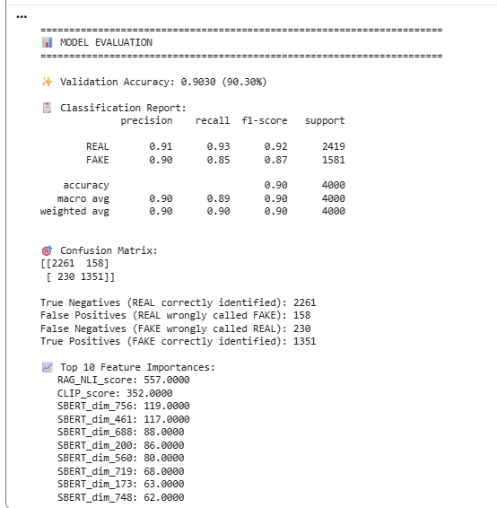
# ============================================================================
# ✅ COLAB CELL 13 — Save Models and Assets
# ============================================================================

print("\n💾 Saving models and assets...")

# Save LightGBM model
model.booster_.save_model(f'{BASE_PATH}/lightgbm_model.txt')
print("✅ LightGBM model saved")

# Save scaler
joblib.dump(scaler, f'{BASE_PATH}/scaler.pkl')
print("✅ Scaler saved")

# Save FAISS index
faiss.write_index(faiss_index, f'{BASE_PATH}/faiss_index.bin')
print("✅ FAISS index saved")

# Save evidence corpus
evidence_corpus = {
'texts': evidence_df["clean_title"].tolist(),
'labels': evidence_df["2_way_label"].tolist(),
'embeddings': evidence_embeddings
}
with open(f'{BASE_PATH}/evidence_corpus.pkl', 'wb') as f:
pickle.dump(evidence_corpus, f)
print("✅ Evidence corpus saved")

# Save metadata
metadata = {
'accuracy': accuracy,
'sample_size': len(df),
'evidence_size': len(evidence_df),
'feature_dims': X.shape[1],
'models': {
'text': 'all-mpnet-base-v2',
'clip': 'clip-vit-base-patch32',
'nli': 'bart-large-mnli',
'classifier': 'lightgbm'
}
}
with open(f'{BASE_PATH}/metadata.pkl', 'wb') as f:
pickle.dump(metadata, f)
print("✅ Metadata saved")

print(f"\n✨ All assets saved to: {BASE_PATH}")

# ============================================================================
# ✅ COLAB CELL 14 — Inference for New Input (COMPLETE!)
# ============================================================================

def predict_news(text, image_url=None, verbose=True):
"""
Predict if news is REAL or FAKE using multimodal RAG-NLI system

Args:
text: News headline
image_url: Optional image URL
verbose: Print detailed analysis

Returns:
label: "REAL" or "FAKE"
confidence: 0-1 probability
evidence_texts: Retrieved evidence articles
"""
if verbose:
print("\n" + "="*70)
print("🔍 MULTIMODAL FAKE NEWS ANALYSIS")
print("="*70)
print(f"\n📰 Headline: {text}")

# 1. Text embedding (SBERT)
text_vec = text_model.encode([text], convert_to_numpy=True)

# 2. CLIP score (image-text alignment)
clip_score = 0.0
if image_url:
image = load_image(image_url)
if image:
try:
inputs = clip_processor(
text=text,
images=image,
return_tensors="pt",
padding=True
).to(device)

with torch.no_grad():
clip_score = clip_model(**inputs).logits_per_image.item()

if verbose:
print(f"\n🎨 Image-Text Alignment (CLIP): {clip_score:.2f}")
except:
if verbose:
print("\n⚠️ Could not process image")

# 3. RAG retrieval and NLI verification
if verbose:
print(f"\n🔎 Retrieving evidence from {faiss_index.ntotal} real news articles...")

D, I = faiss_index.search(text_vec, k=3)
evidence_texts = [evidence_df.iloc[i]["clean_title"] for i in I[0]]

if verbose:
print(f"\n📚 Evidence Analysis (NLI Verification):")

nli_scores = []
for idx, evidence in enumerate(evidence_texts):
score = nli_verify(text, evidence)
nli_scores.append(score)

if verbose:
if score > 0.3:
verdict = "❌ CONTRADICTS"
color = "red"
elif score < -0.3:
verdict = "✅ SUPPORTS"
color = "green"
else:
verdict = "⚪ NEUTRAL"
color = "gray"

print(f"\n [{idx+1}] {verdict} (NLI: {score:+.3f})")
print(f" \"{evidence[:65]}...\"")

rag_score = np.mean(nli_scores)

if verbose:
print(f"\n🧮 Average NLI Score: {rag_score:+.3f}")
if rag_score > 0.2:
print(" 💡 Evidence CONTRADICTS claim → Likely FAKE")
elif rag_score < -0.2:
print(" 💡 Evidence SUPPORTS claim → Likely REAL")
else:
print(" 💡 Evidence is NEUTRAL/UNCLEAR")

# 4. Combine features
final_vec = np.hstack([text_vec, [[clip_score]], [[rag_score]]])
final_vec = scaler.transform(final_vec)

# 5. Predict
prediction = model.predict(final_vec)[0]
confidence = model.predict_proba(final_vec)[0]

label = "FAKE" if prediction == 1 else "REAL"
conf_value = confidence[prediction]

if verbose:
print(f"\n{'='*70}")
print(f"🎯 FINAL PREDICTION: {'🔴 ' + label if label == 'FAKE' else '🟢 ' + label}")
print(f"{'='*70}")
print(f" Confidence: {conf_value:.1%}")
print(f" Probability → REAL: {confidence[0]:.1%} | FAKE: {confidence[1]:.1%}")
print(f"\n📊 Feature Breakdown:")
print(f" • Text Semantics (SBERT): 768 dimensions")
print(f" • Image Alignment (CLIP): {clip_score:.2f}")
print(f" • Evidence Verification (NLI): {rag_score:+.3f}")
print("="*70)

return label, conf_value, evidence_texts

print("✅ Inference function ready!")

# ============================================================================
# ✅ COLAB CELL 15 — Test Predictions
# ============================================================================

print("\n" + "="*70)
print("🧪 TESTING ON SAMPLE ARTICLES")
print("="*70)

# Test on validation set samples
test_samples = [
df[df["2_way_label"] == 1].sample(1).iloc[0], # Fake news
df[df["2_way_label"] == 0].sample(1).iloc[0], # Real news
]

for sample in test_samples:
actual_label = "FAKE" if sample["2_way_label"] == 1 else "REAL"
print(f"\n{'='*70}")
print(f"📌 ACTUAL LABEL: {actual_label}")

pred_label, conf, evidence = predict_news(
text=sample["clean_title"],
image_url=sample["image_url"],
verbose=True
)
o/p for this block:
======================================================================
🧪 TESTING ON SAMPLE ARTICLES
======================================================================

======================================================================
📌 ACTUAL LABEL: FAKE

======================================================================
🔍 MULTIMODAL FAKE NEWS ANALYSIS
======================================================================

📰 Headline: this pennie has all of its copper worn of and its only from the s

🎨 Image-Text Alignment (CLIP): 29.37

🔎 Retrieving evidence from 12094 real news articles...

📚 Evidence Analysis (NLI Verification):

[1] ❌ CONTRADICTS (NLI: +0.784)
"cocim bent nickel..."

[2] ❌ CONTRADICTS (NLI: +0.722)
"scarlinebills coins..."

[3] ❌ CONTRADICTS (NLI: +0.955)
"this happy embedded metal chunk..."

🧮 Average NLI Score: +0.820
💡 Evidence CONTRADICTS claim → Likely FAKE

======================================================================
🎯 FINAL PREDICTION: 🔴 FAKE
======================================================================
Confidence: 100.0%
Probability → REAL: 0.0% | FAKE: 100.0%

📊 Feature Breakdown:
• Text Semantics (SBERT): 768 dimensions
• Image Alignment (CLIP): 29.37
• Evidence Verification (NLI): +0.820
======================================================================

======================================================================
📌 ACTUAL LABEL: REAL

======================================================================
🔍 MULTIMODAL FAKE NEWS ANALYSIS
======================================================================

📰 Headline: victory to the national liberation struggles in southern afrika circa

🎨 Image-Text Alignment (CLIP): 34.16

🔎 Retrieving evidence from 12094 real news articles...

📚 Evidence Analysis (NLI Verification):

[1] ✅ SUPPORTS (NLI: -0.908)
"victory to the national liberation struggles in southern afrika c..."

[2] ❌ CONTRADICTS (NLI: +0.999)
"the beginning of south africa colonization from the british..."

[3] ❌ CONTRADICTS (NLI: +0.466)
"always faithful to the way of south africa south african wwii rec..."

🧮 Average NLI Score: +0.186
💡 Evidence is NEUTRAL/UNCLEAR

======================================================================
🎯 FINAL PREDICTION: 🟢 REAL
======================================================================
Confidence: 99.6%
Probability → REAL: 99.6% | FAKE: 0.4%

📊 Feature Breakdown:
• Text Semantics (SBERT): 768 dimensions
• Image Alignment (CLIP): 34.16
• Evidence Verification (NLI): +0.186

# ============================================================================
# ✅ COLAB CELL 16 — Custom Prediction Examples
# ============================================================================

print("\n" + "="*70)
print("🆕 CUSTOM PREDICTION EXAMPLES")
print("="*70)

# Example 1: Likely fake
predict_news(
text="Scientists discover aliens living in ocean depths",
image_url=None,
verbose=True
)

# Example 2: Likely real
predict_news(
text="President announces new infrastructure initiative",
image_url=None,
verbose=True
)

# Example 3: Your own!
# predict_news(
# text="YOUR HEADLINE HERE",
# image_url="YOUR IMAGE URL HERE",
# verbose=True
# )
Final o/p iam getting :
======================================================================
🆕 CUSTOM PREDICTION EXAMPLES
======================================================================

======================================================================
🔍 MULTIMODAL FAKE NEWS ANALYSIS
======================================================================

📰 Headline: Scientists discover aliens living in ocean depths

🔎 Retrieving evidence from 12094 real news articles...

📚 Evidence Analysis (NLI Verification):

[1] ❌ CONTRADICTS (NLI: +0.489)
"did intelligent space aliens once live in our solar system..."

[2] ✅ SUPPORTS (NLI: -0.918)
"aliens..."

[3] ✅ SUPPORTS (NLI: -0.918)
"aliens..."

🧮 Average NLI Score: -0.449
💡 Evidence SUPPORTS claim → Likely REAL

======================================================================
🎯 FINAL PREDICTION: 🟢 REAL
======================================================================
Confidence: 99.9%
Probability → REAL: 99.9% | FAKE: 0.1%

📊 Feature Breakdown:
• Text Semantics (SBERT): 768 dimensions
• Image Alignment (CLIP): 0.00
• Evidence Verification (NLI): -0.449
======================================================================

======================================================================
🔍 MULTIMODAL FAKE NEWS ANALYSIS
======================================================================

📰 Headline: President announces new infrastructure initiative

🔎 Retrieving evidence from 12094 real news articles...

📚 Evidence Analysis (NLI Verification):

[1] ⚪ NEUTRAL (NLI: +0.086)
"donald trump first signed order as president jan..."

[2] ❌ CONTRADICTS (NLI: +0.933)
"future us sec of african affairs malik obama makes a groundbreaki..."

[3] ❌ CONTRADICTS (NLI: +0.907)
"donald trump meets with engineers who say a mile metal wall is un..."

🧮 Average NLI Score: +0.642
💡 Evidence CONTRADICTS claim → Likely FAKE

======================================================================
🎯 FINAL PREDICTION: 🔴 FAKE
======================================================================
Confidence: 99.9%
Probability → REAL: 0.1% | FAKE: 99.9%

📊 Feature Breakdown:
• Text Semantics (SBERT): 768 dimensions
• Image Alignment (CLIP): 0.00
• Evidence Verification (NLI): +0.642
======================================================================
('FAKE',
np.float64(0.9992296805596261),
['donald trump first signed order as president jan',
'future us sec of african affairs malik obama makes a groundbreaking suggestion',
'donald trump meets with engineers who say a mile metal wall is unfeasible'])

Intial output without inclusion of LLM layer:
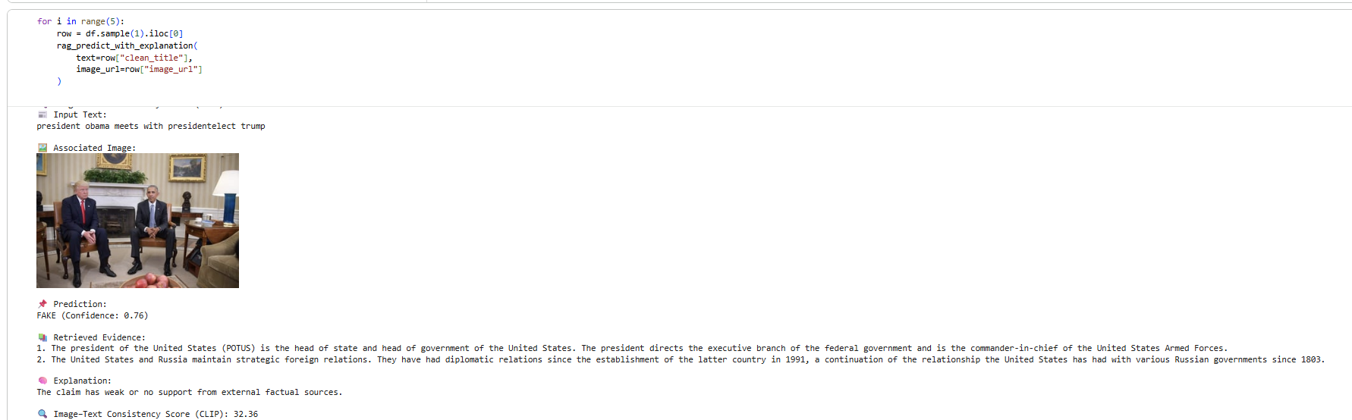

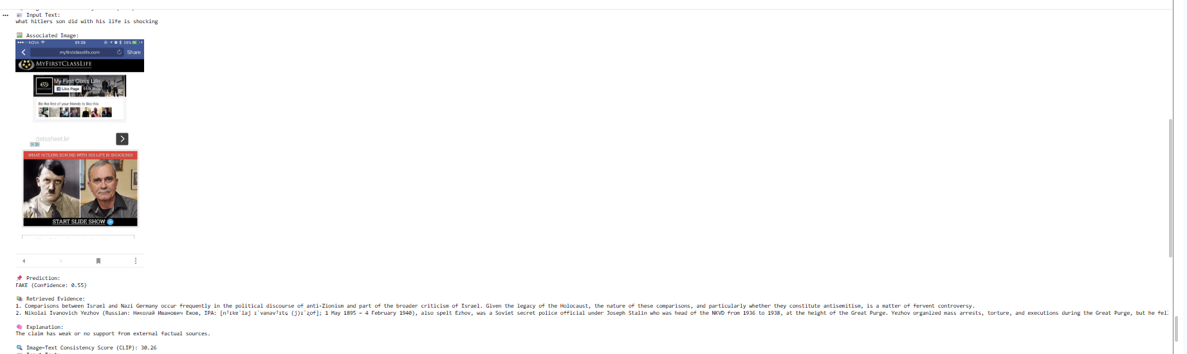

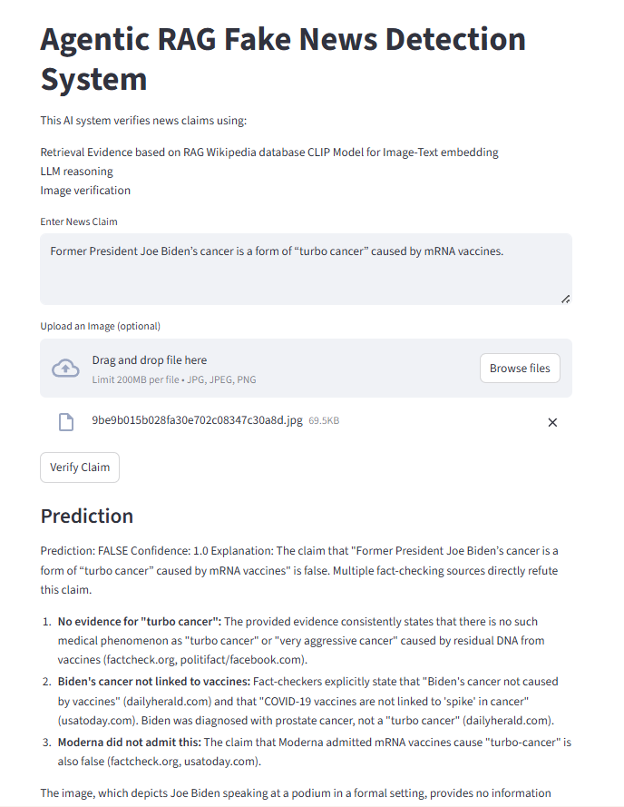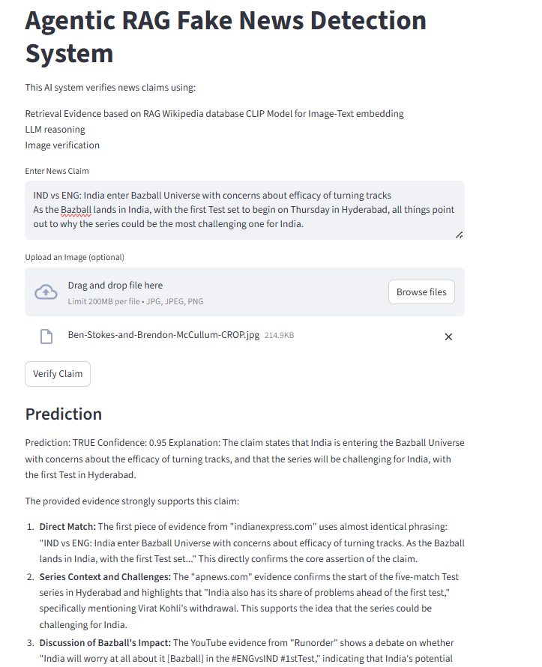

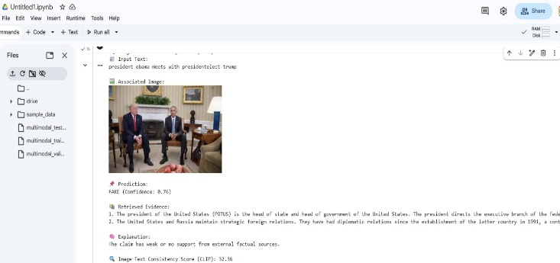

Early research in fake news detection primarily relied on textual analysis using classical machine learning techniques. Several studies evaluated the effectiveness of traditional classifiers such as Logistic Regression, Support Vector Machines, Random Forests, and Naïve Bayes in combination with handcrafted linguistic features or TF-IDF representations. Comparative analyses demonstrated that while convolutional neural networks can outperform classical machine learning models on certain datasets, both approaches remain fully supervised and limited to textual cues [Benaouda et al., 2024]. Similar findings were reported in NLPdriven fake news detection studies that employed Bag-of-Words and TF-IDF features with 5 standard classifiers, achieving competitive accuracy while remaining sensitive to feature engineering choices and dataset-specific patterns [Coban and Bakal, 2025]. Additional investigations explored lightweight machine learning pipelines combining TF-IDF representations with linear and tree-based classifiers, highlighting their computational efficiency and ease of deployment [Gupta et al., 2022]. With the advancement of deep learning, hybrid architectures integrating contextual embeddings and sequential models were introduced to improve semantic understanding of news content. In particular, BERT-CNN-BiLSTM architectures demonstrated improved classification performance by capturing contextual and temporal dependencies within text [Alghamdi et al., 2022]. 2.1.2 Multimodal Fake News Detection To address the limitations of text-only methods, recent research has increasingly focused on multimodal fake news detection by jointly modeling textual and visual information. Multimodal frameworks integrating BERT-based textual encoders with convolutional neural network-based image feature extractors have been shown to improve detection performance compared to unimodal baselines by capturing complementary cross-modal signals [Reddy et al., 2025]. Further studies explored multimodal interaction mechanisms using unsupervised feature fusion strategies to model correlations between text and images more effectively [Geng et al., 2025].

Due to the limited availability of labeled fake news data, several studies have investigated semisupervised learning approaches to leverage large volumes of unlabeled content. Graph-based semi-supervised frameworks have been proposed to propagate labels across similarity graphs constructed using textual embeddings, demonstrating that competitive detection performance can be achieved with significantly fewer labeled samples [Guacho et al., 2018]. Subsequent 6 research extended this direction by employing convolutional neural networks within semisupervised learning settings to exploit unlabeled social media data more effectively [Mansouri et al., 2020]. Recent studies leveraged CLIP-based representations to directly model image–text semantic alignment for fake news detection. CLIP-based frameworks demonstrated effectiveness in identifying inconsistencies between visual and textual content by computing similarity scores between modalities [Zhou et al., 2022]. More recent studies combined semi-supervised learning with graph neural networks to propagate credibility labels across social or content-based graphs, showing improved robustness under limited supervision [Benamira et al., 2019].

[1] W. Benaouda, S. Ouamour, and H. Sayoud, “Comparison of CNN model with different machine learning models for fake news detection,” in Proc. Int. Conf. Electrical, Computer, Telecommunication and Energy Technologies (ECTETech), 2024, pp. 1–6.
[2] M. K. Çoban and G. Bakal, “NLP-driven fake news detection: A machine learning perspective,” in Proc. Int. Congr. Human-Computer Interaction, Optimization and Robotic Applications (ICHORA), 2025, pp. 1–6.
[3] V. Gupta, R. S. Mathur, T. Bansal, and A. Goyal, “Fake news detection using machine learning,” in Proc. Int. Conf. Machine Learning, Big Data, Cloud and Parallel Computing (COM-IT-CON), 2022, pp. 84–89.
[4] J. Alghamdi, Y. Lin, and S. Luo, “Modeling fake news detection using BERT-CNN-BiLSTM architecture,” in Proc. IEEE Int. Conf. Multimedia Information Processing and Retrieval (MIPR), 2022, pp. 354–359.
[5] K. R. Reddy, P. Pragnya, D. P. Reddy, S. B. Sumanth, and P. M. Jyosthna, “Multimodal fake news detection with MF-BERT,” in Proc. Int. Conf. Computing Technologies (ICOCT), 2025, pp. 1–6.
[6] Y. Geng, “Fake news detection with multimodal interaction and unsupervised learning fusion,” in Proc. IEEE Int. Conf. Image Processing and Computer Applications (ICIPCA), 2025, pp. 187–193.
[7] G. B. Guacho, S. Abdali, N. Shah, and E. E. Papalexakis, “Semi-supervised content-based detection of misinformation via tensor embeddings,” in Proc. IEEE/ACM Int. Conf. Advances in Social Networks Analysis and Mining (ASONAM), 2018, pp. 322–325.
[8] R. Mansouri, M. Naderan-Tahan, and M. J. Rashti, “A semi-supervised learning method for fake news detection in social media,” in Proc. Iranian Conf. Electrical Engineering (ICEE), 2020, pp. 1–6.
[9] Y. Zhou, Q. Ying, Z. Qian, S. Li, and X. Zhang, “Multimodal fake news detection via CLIP-guided learning,” in Proc. ACM Int. Conf. Multimedia, 2022, pp. 1–11.
[10] A. Benamira, B. Devillers, E. Lesot, A. K. Ray, M. Saadi, and F. D. Malliaros, “Semi-supervised learning and graph neural networks for fake news detection,” in Proc. Int. Conf. Advances in Social Networks Analysis and Mining (ASONAM), 2019, pp. 568–575.

